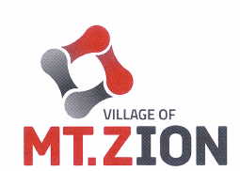

MT ZION BOARD OF POLICE COMMISSIONERS 410 W. Main Street Brad Allen, Chairman Mt. Zion, Illinois 62549
Bob Kistenfeger, Secretary Phone 217.864. 4012
Jennifer Harris, Member At Large Fax 217.864.4130

Mount Zion Board of Police Commissioners
April 14, 2021
7:00 pm

Location
Mount Zion Police Department – Training Room
410 West Main Street
Mount Zion, IL
AGENDA

- Call to Order

- Roll Call

- Public Forum- Public Comment limited to 5 minutes per citizen

- Approval of Minutes

- Executive Session- Section 2 (c) (1)- The appointment, employment, compensation, discipline, performance, or dismissal of specific employee of the public body or legal counsel for the public body- None Scheduled

- Old Business
- Current roster vacancy

7. New Business
a. Rules Changes- discussion only
1. MZPC Rules and Regulations Section 3 (i) Qualifications
2. MZPD Rules and Regulations Section 11- Lateral Entry Procedures

b. Application Form- discussion only
1. Updated Application Packet

- Police Department Status Report

- Commissioner items

- Adjournment
Next Regular Meeting – July 14, 2021

