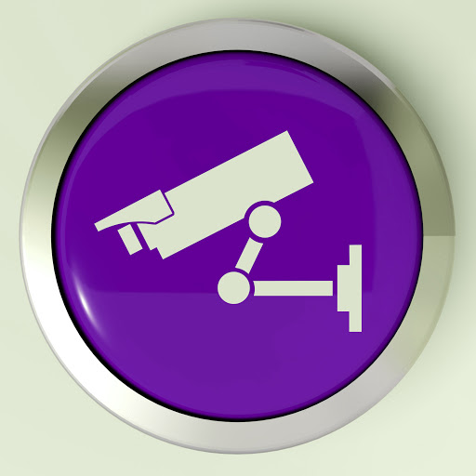

Camera Registration
The Mt. Zion Police Department believes in working with our residents helps to improve public safety and solve crimes. To that end we have created a private security camera registration program that is designed to deter crime and promote public safety.
By filling out this form, citizens and business owners can register their EXTERNAL security camera locations, system details, and submit their contact information. When a crime is committed, officers can check for cameras registered in the area. We then know to contact that party and ask them to review their security footage. In the past, the MZPD has recovered valuable evidence from private security cameras, including suspect description and suspect vehicle information. If you wish to help the MZPD in our mission to solve and deter criminal activity please complete this form. Completed forms can be returned in person to the Mt. Zion Police Department or emailed to Detective Corey Janes at coreyjanes@mtzion.com

Name: ___________________________________
Address: ___________________________________
___________________________________
Phone: ___________________________________
Email: ___________________________________
Type of Camera: __________________________________
Location of
Of Camera: ___________________________________

